Are you promoting Health Savings Account (HSA) as retirement accounts?

This calculator will help you demonstrate the value of a consumer having an HSA account and how much they should be saving to meet their retirement goals.

Access the WEX Health Health Savings Account Goal Calculator [here](http://www.wexhealthinc.com/calc/HSAGoal.html).

Share this link with your clients and their employees to help educate on the value of an HSA.

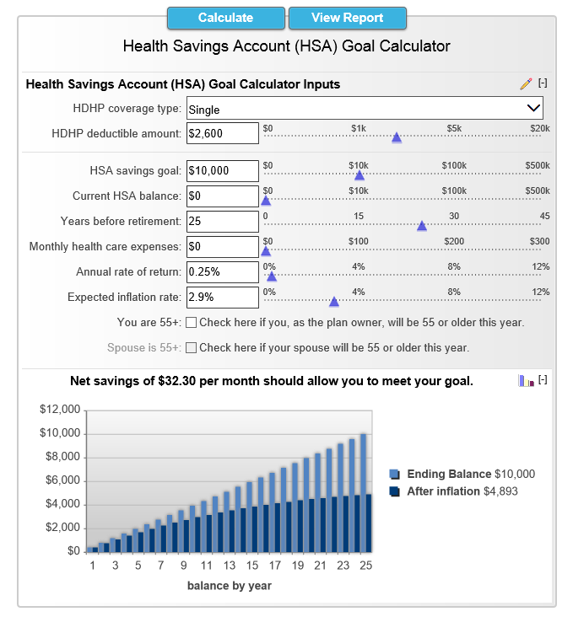

**How to Use the Calculator:**

Select your coverage type

Type in your deductible amount

Enter in:

* your savings goal
* current HSA balance
* how many years you have left before retirement
* your estimated monthly health expenses

Adjust the average rate of return and inflation rate as needed

Hit Calculate and then click View Report

**Definitions**

**Health Savings Account (HSA):** An HSA is a tax-advantaged account established to pay for qualified medical expenses of an account holder who is covered under a high-deductible health plan. With money from this account, you pay for health care expenses until your deductible is met. Any unused funds are yours to retain in your HSA and accumulate towards your future health care expenses or your retirement.

In order to put money into an HSA you are required to have a High Deductible Health Plan (HDHP) in effect for either you or your family. A HDHP is simply health insurance that meets certain minimum deductible and maximum out-of-pocket expense requirements. The table below shows the limits for HSA's in 2017 & 2018.



**High Deductible Health Plan (HDHP) deductible amount:** Your HDHP deductible amount is the amount you pay toward your own medical expenses, in a given year, before your insurance begins to cover any expenses. In 2018, for a HDHP, the minimum deductible amount is $1,350 for self-only coverage and $2,700 for family coverage.

**High Deductible Health Plan (HDHP) coverage type:** Choose the insurance coverage type for your HDHP. Your choices are 'Family' or 'Single'.

**HSA savings goal:** The amount you wish to have in your HSA account when you retire.

**Years before retirement:** The number of years you will be able to save (contribute) into your HSA before you retire.

**Current Health Savings Account (HSA) balance:** The total amount currently saved in your HSA.

**Monthly health care expenses:** The amount per month you expect to spend on qualifying medical expenses.

**Annual rate of return:** This is the annual rate of return you expect to receive on your HSA funds. The actual rate of return is largely dependent on the types of investments you select. The Standard & Poor's 500® (S&P 500®) for the 10 years ending Dec. 1st, 2015, had an annual compounded rate of return of 7.76%, including reinvestment of dividends. From January 1970 through to Dec. 2015, the average annual compounded rate of return for the S&P 500®, including reinvestment of dividends, was approximately 10.5% (source: www.standardandpoors.com). Since 1970, the highest 12-month return was 61% (June 1982 through June 1983). The lowest 12-month return was -43% (March 2008 to March 2009). Savings accounts at a financial institution may pay as little as 0.25% or less but carry significantly lower risk of loss of principal balances.

It is important to remember that these scenarios are hypothetical and that future rates of return can't be predicted with certainty and that investments that pay higher rates of return are generally subject to higher risk and volatility. The actual rate of return on investments can vary widely over time, especially for long-term investments. This includes the potential loss of principal on your investment. It is not possible to invest directly in an index and the compounded rate of return noted above does not reflect sales charges and other fees that Separate Account investment funds and/or investment companies may charge.

**Expected inflation rate:** This is what you expect for the average long-term inflation rate. A common measure of inflation in the U.S. is the Consumer Price Index (CPI). From 1925 through 2015 the CPI has a long-term average of 2.9% annually. Over the last 40 years highest CPI recorded was 13.5% in 1980. For 2015, the last full year available, the CPI was 0.0% annually as reported by the Minneapolis Federal Reserve.

**You are 55+** Check here if you, as the plan owner, will be 55 or older this year. Your age is used to determine if you are eligible to contribute additional catch-up contributions to your HSA. If you are 55 or older and your HDHP is in effect, you are eligible to deposit catch-up contributions. For 2018, the additional amount is $1000, which is unchanged from 2015. By checking the box you are indicating you are 55 or older this year and are still covered by an HDHP.

Catch-up contributions are not prorated. You can deposit the entire amount into your HSA as long are 55 or older at some point during the year.

**Spouse is 55+** Check here if your spouse will be 55 or older this year. Your spouse's age is used to determine what catch-up contribution amount they can deposit into their own HSA. By checking the box you are indicating your spouse is 55 or older this year and that they are eligible to contribute into an HSA. Please note, your spouse must have an HSA account established in their name and be eligible to make contributions into that account. For example, if your spouse is covered by your family HDHP and is over 55, but has enrolled in Medicare, they would be ineligible to make a catch-up contribution.