Are you promoting Health Savings Account (HSA) as retirement accounts?
This calculator will help you demonstrate the value of a consumer having an HSA account and how much they should be saving to meet their retirement goals. This calculator uses the 2019 withholding schedules, rules and rates (IRS Publication 15).

Access the WEX Health Health Savings Account Goal Calculator here. Or view all available WEX Health calculators here.
Share this link with your clients and their employees to help educate on the value of an HSA.

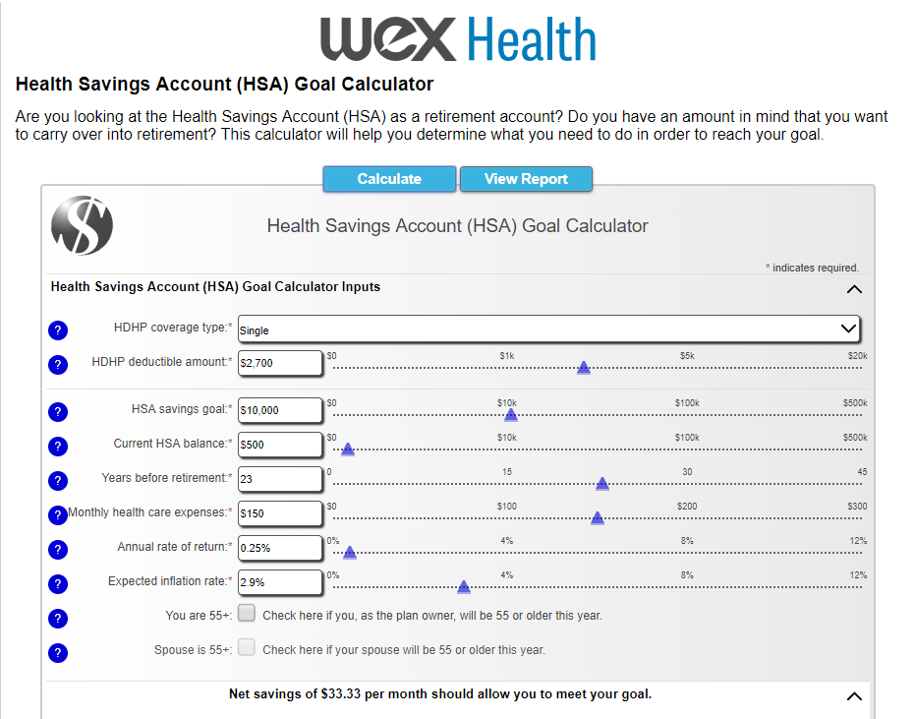

How to Use the Calculator:
Select your coverage type
Type in your deductible amount
Enter in:
- your savings goal
- current HSA balance
- how many years you have left before retirement
- your estimated monthly health expenses
Adjust the average rate of return and inflation rate as needed
Hit Calculate and then click View Report
